**Software Issue Report and Enhancement Recommendations**

**Critical Issues**

**1. Contact Form Validation**

**Issue:** The contact form allows submission of empty messages without proper validation.

**Steps to Reproduce:** Navigate to Contact → Click "Send Message" without entering any data

**Result:** Empty message is successfully submitted

**Impact:** Data integrity issues and potential spam

Evidence:

**2. About Us Media Loading Error**

**Issue:** The "About Us" page displays a media loading error.

**Error Message:** "The media could not be loaded, either because the server or network failed or because the format is not supported."

**Impact:** Poor user experience and incomplete page functionality

Evidence:

**3. Cart and Order Processing Issues**

**3a. Payment Form Validation**

**Issue:** The order form lacks proper validation for payment fields.

**Example:** Invalid year entries like "e20026" are accepted in credit card fields

**Impact:** Potential payment processing failures and security concerns

Evidence:

**3b. Empty Cart Processing**

**Issue:** Users can place orders with empty shopping carts.

**Expected Behaviour:** The "Place Order" button should be disabled when no items are present in the cart

**Impact:** Unnecessary processing and potential system errors

**User Interface and Experience Issues**

**4. Profile Accessibility**

**Enhancement:** User profile information should be easily accessible after login.

**Recommendation:** Position the profile link in either the top-right or top-left corner for improved user experience and quick access to account details.

**5. Gallery Display Limitations**

**Issues Identified:**

* Homepage gallery only displays Mobiles and Laptops, excluding Monitors
* Gallery content does not update based on selected category
* After adding items to cart, users remain on the same page

**Recommendations:**

* Include all product categories (Monitors, Mobiles, Laptops) in the homepage gallery
* Implement dynamic gallery filtering based on category selection
* Redirect users to homepage or previous page after adding items to cart for continued shopping

**6. Cart Functionality Issues**

**6a. Quantity Selection**

**Issue:** Users must repeatedly click "Add to Cart" to add multiple quantities of the same product. **Current Behaviour:** Each click creates a separate cart entry for the same product

**Recommendation:** Implement quantity selector allowing users to specify desired number of items in a single action

**6b. Cart Order Consistency**

**Issue:** Product order in cart changes unpredictably when items are deleted or user navigated back to Cart page after visiting some other tab.

**Impact:** Confusing user experience and difficulty in cart management

**6c. Product Details Access**

**Issue:** No mechanism to view product details from within the cart.

**Recommendation:** Provide links or buttons allowing users to review product specifications from the cart page

**6d. Cart Pagination and Navigation**

**Issue:** Cart lacks pagination functionality for managing large numbers of items, causing layout and usability problems.

**Current Behaviour:** When cart contains numerous items (e.g., 20+ products), users must scroll extensively to view all items

Evidence: missing menu

**Specific Problems:**

* Website headers are not fixed during vertical scrolling
* Excessive scrolling disrupts website alignment and user experience
* No efficient way to navigate through large cart contents

**Recommendation:** Implement pagination controls allowing users to navigate through cart items in manageable segments while maintaining fixed headers and consistent page layout

**7. Navigation and Layout Issues**

**7a. Duplicate Navigation Elements**

**Issue:** "About Us" link appears twice - at the top and bottom of the website

**Impact:** Redundant navigation and potential user confusion

**7b. Inconsistent Header Layout**

**Issue:** Navigation links/tabs(Home, Contact, About Us etc.,) placement in the header changes unpredictably

**Impact:** Poor user experience and navigation difficulties

**Evidence:**

**Menu placement when the user is on Home page**

**Menu placement changed when the user clicked on Cart**

**7c. Gallery Navigation Bug**

**Issue:** Repeatedly clicking the left/right arrow ('<'or’ >‘) in the gallery approximately 10 times causes screen misalignment, hiding website headers

**Impact:** Broken user interface and navigation loss

**Evidence: Missing menu and headers**

**8. Product Display Issues**

**8a. Limited Product Images**

**Issue:** When the user selects a specific product, only single product image displayed on the product details page despite indicators suggesting multiple images are available (three ‘–‘ visible)

**Expected Behaviour:** Full image gallery should be accessible when multiple images are available

**8b. Contact Form Email Validation**

**Issue:** Email field accepts invalid formats and special characters

**Example:** "lakshmdadaan$"£%%%" is accepted as valid email

**Impact:** Data quality issues and potential communication failures

**Evidence:**

**9. Rapid Click Handling – Performance degradation**

**Issue:** Users can click "Add to Cart" multiple times in quick succession without waiting for the "Product Added" dialog to close

**Impact:** Potential duplicate entries and system performance issues

**Recommendation:** Implement click throttling or disable button during processing

**Evidence:**

**Priority Recommendations**

1. **High Priority:** Implement proper form validation across all user input fields
2. **High Priority:** Fix cart functionality and quantity management
3. **Medium Priority:** Resolve navigation consistency issues
4. **Medium Priority:** Enhance gallery functionality and product display
5. **Low Priority:** Improve user interface layout and accessibility

**10. Session Management**

**Issue:** When a user logs into the site on Chrome (or any browser) and adds products to the cart, copying the browser link and accessing it via a new incognito tab still allows the user to view all previously added products.

**Impact:** This indicates improper session isolation and exposes user data across sessions

**11. Authentication Across Browsers**

**Issue:** When the site is accessed via Chrome and added the required products to cart without logging in. Then you access the site on Firefox or Edge or a new incognito mode, all products added on Chrome remain accessible.

**Impact:** Demonstrates inconsistent session/cookies sharing across different browsers and poses a risk.

**12. Mobile View Header Alignment**

**Issue:** Headers are not properly aligned when the website is accessed on mobile devices.

**Impact:** Results in a suboptimal user interface and potential confusion for users.

**13. Order Confirmation Dialog Behaviour**

**Issue:** Upon clicking 'Place Order,' the dialog box displaying 'Thank you for your purchase!' allows the background form to be visible and scrollable.

**Impact:** Users should not be able to interact with background elements while the dialog is active; this affects transactional integrity and user experience.

**Evidence:**

Refer below

**14. Duplicate ID Generation**

**Issue:** Each click on 'Purchase' button present just below the dialog box bearing the 'Thank you for your purchase!' message generates a new identifier in the dialog details.

**Impact:** This can lead to confusion and possible inconsistencies in order tracking.

**Evidence:**

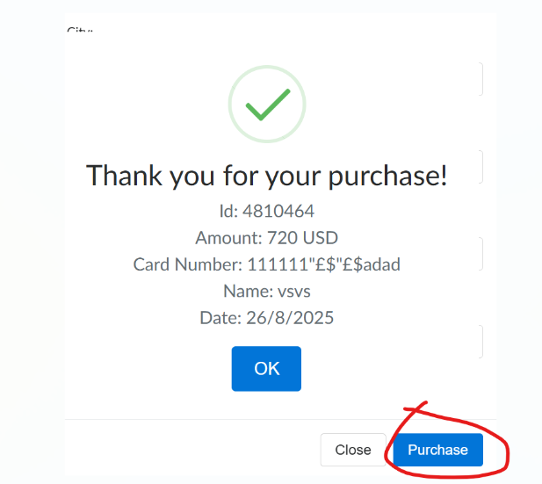

**Conclusion**

These issues significantly impact user experience, data integrity, security, performance and system reliability. Addressing the critical issues first, particularly form validation and cart functionality, should be prioritized to ensure proper system operation and user satisfaction.